**PROBLEM FORMULATION & INTERPRETATION by Kevin George**

**Sets:-**  
Time – Set of Time; {1(10AM),2(11AM),3(12Noon),4(1PM),5(2PM),6(3PM),7(4PM),8(5PM),9(6PM),10(7PM)}   
Full – Set of fulltime shift; { F1,F2,F3}  
Part- Set of Part time Shift; {P1,P2}

**Parameters:-**

${Fullpay}_{i}$ = salary of full time employee in each fulltime shift i, i $∈$ Full {160,160,160}

${Partpay}_{i}$ = salary of part time employee in each Part time shift i, i $∈$ Part {75,75}

${Checks}_{i}$ = checks processed in hour i , i $∈$ Time

${MaxMachine}_{i}$ = maximum number of machine in each time i, i $∈$ Time

${Received}_{i}$ = max checks received in each time i, i $∈$ Time

${Iteration1}_{i,j}$ =presence used for full time worker for all i $∈$ time and j $∈$ Full

${Iteration2}_{i,j}$ = presence used for part time worker for all i $∈$ time and j $∈$ Part.

Minworker = min number of full time worker.

**Decision Variable:-**

$F_{i}$ = number of full time worker in each full time shift i , i $∈$ Full

$P_{i}$ = number of part time worker in each part time shift i , i $∈$ Part

$I_{i}$ = number of inventory of check in each hour i , i $∈$ Time

**Objective Function:-**

Mincost= $\sum{F_{j}*}{Fullpay}_{j}$ + $\sum{P_{i}*{Partpay}_{i}}$ $∀ j in Full ,$ i in Part.

**Constraints:-**

1. $\sum{F_{i}> Minworker }∀ i in Full$ {min number of full time worker constraint}
2. $\sum_{jϵFull }{{Iteration1}_{i,j}*}F_{j}$ + $\sum_{kϵPart }{{Iteration2}_{i,k}*}P_{k}$ <= ${MaxMachine}_{i}$ $∀ i in Time$ {max number of workers in each hour constraint}
3. If: i=1 ,i in Time

$\sum_{jϵFull }{{Iteration1}_{i,j}*}F_{j}$ ${Checks}_{i}$* + $\sum_{kϵPart }{{Iteration2}_{i,k}*}P_{k}*{Checks}_{i}$ = ${Received}_{i}-I_{i}$ $∀ i in Time$ {checks processed by full&part time people in first hour = Difference of check received in first hour and the inventory leftover of first hour }  
else: $\sum_{jϵFull }{{Iteration1}_{i,j}*}F_{j}$ ${Checks}_{i}$
* + $\sum_{kϵPart }{{Iteration2}_{i,k}*}P_{k}*{Checks}_{i}$ = ${Received}_{i}-I_{i}+$ $I_{i-1} ∀ i in Time$ {checks processed by full&part time people in remaining hour = Difference of check received in each hour and the inventory leftover of that hour + previous inventory}

i=10 ,i in Time

$I_{10}$ =0

**Interpretation:-**

1. 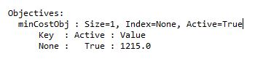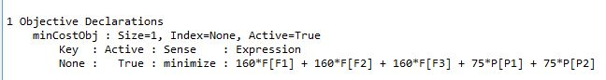Objective function -The minimized cost is 1215
2. F3=3(F1,F2=0) Number of fulltime worker is 3 and works in 3rd shift ie. Noon to 8pm.
3. P2=9.8(P1=0) Number of par time workers =10 and works in 3-8pm shift

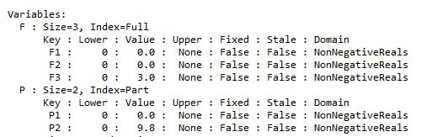

1. Inventory of checks at the end of each hour is tabulated below

D:\RIT\system modelling and optimisation\Homework\HW-4\Capture1.JPGD:\RIT\system modelling and optimisation\Homework\HW-4\Capture.JPG

5) So only Fulltime workers working from noon to 8 and part time workers working from 3pm to 8pm is employed to meet the constraints and minimize the cost of objective function.

6) The number of machine and corresponding people worked is tabulated below.

|  |  |  |  |  |
| --- | --- | --- | --- | --- |
| **Time set** | **Time period** | **Machines worked** | **Number of people worked** | **Comments (people worked)** |
| 1 | 10am-11am | 0 | 0 |  |
| 2 | 11am-noon | 0 | 0 |  |
| 3 | noon-1pm | 3 | 3 | F3 |
| 4 | 1pm-2pm | 3 | 3 | F3 |
| 5 | 2pm-3pm | 3 | 3 | F3 |
| 6 | 3pm-4pm | 13 | 13 | F3+P2 |
| 7 | 4pm-5pm | 13 | 13 | F3+P2 |
| 8 | 5pm-6pm | 13 | 13 | F3+P2 |
| 9 | 6pm-7pm | 13 | 13 | F3+P2 |
| 10 | 7pm-8pm | 13 | 13 | F3+P2 |